SOP: Roster Management (Managers)
Module | Roster Management (Managers)
Who uses it | Project Manager, Assistant Manager, Assistant Team Leader (and Admin / Super Admin)
Version | 1.0
Issued | 21 Oct 2026
Screenshots are taken from the HRMS test copy. Names, dates and numbers are examples only.

1. Purpose
The roster says, for every employee and every day of the month, whether they work (day or night shift, full or half day), are on week off, holiday or leave, or have left. Targets, billable hours and KRA are calculated from it, so every change goes to admin for approval.

2. Who can do what
Action | Who
View and edit days, leave, Left | Project Manager, Assistant Manager, Assistant Team Leader, Admin, Super Admin
Generate missing rosters, Excel upload, submit for approval | Same as above
See all teams (Team filter) | Project Manager, Admin, Super Admin. Assistant Managers and Team Leaders see their own team only.
Approve / reject, lock / unlock, send roster email, reset, edit holidays | Admin and Super Admin only (see SOP - Admin - Roster)

3. Screen guide - Roster Calendar
Manage > Roster Management. Tabs: Roster Calendar (the grid), My Submissions (your changes), Holiday Master (holidays). Admins also see Approval Queue.
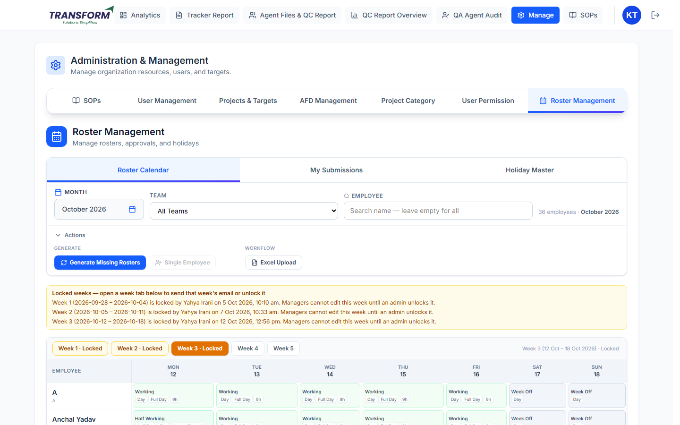
Figure 1: Roster Calendar
- Month: the roster month. Team: filter by team (PM / Admin). Employee: type a name; leave empty for all. When exactly one employee matches, 'single actions ready' appears.
- Actions > Generate: Generate Missing Rosters (creates rosters only for employees who have none for the month), Single Employee (for the one matching employee), Generate Next Month Rosters (shown at the end of the month).
- Actions > Workflow: Excel Upload (download / upload a week in Excel).
- Yellow banner 'Locked weeks' lists weeks admin has locked, who locked them and when.
- Week tabs (Week 1 ... Week 5) switch the grid. Locked weeks are marked '· Locked'.
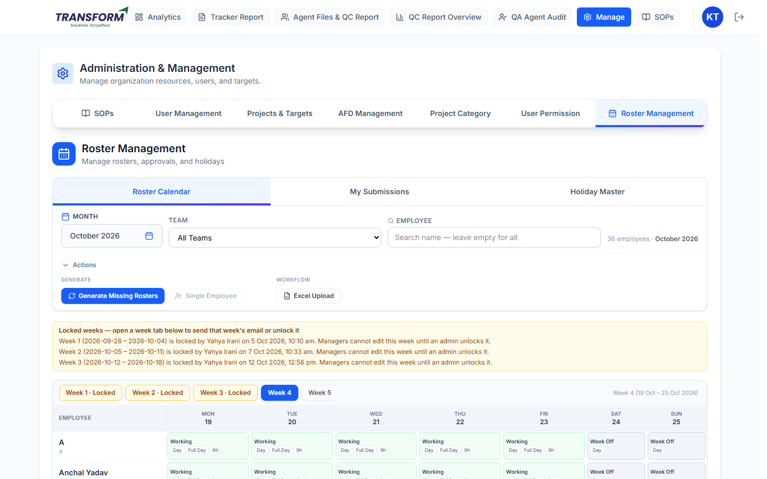
Figure 2: An editable week
- Each cell shows the day type (Working, Half Working, Week Off, Leave, Holiday, Left) and badges such as Day / Night, Full Day / Half and hours.
- An amber dot on a cell means a change is saved but not yet approved.
- Cells cannot be clicked when the week or month is locked, or when that week already has a change waiting for approval.

4. Procedure - Generate rosters
1. Choose the Month. Click Generate Missing Rosters and Confirm. Existing rosters are not changed; the message shows how many were created and skipped.
2. For one new joiner: type their name in Employee until only they remain, then click Single Employee.
3. At month end, Generate Next Month Rosters creates next month's rosters for everyone who has none.

5. Procedure - Change a day
1. Open the week tab and click the employee's day. The Edit Roster Day window opens.
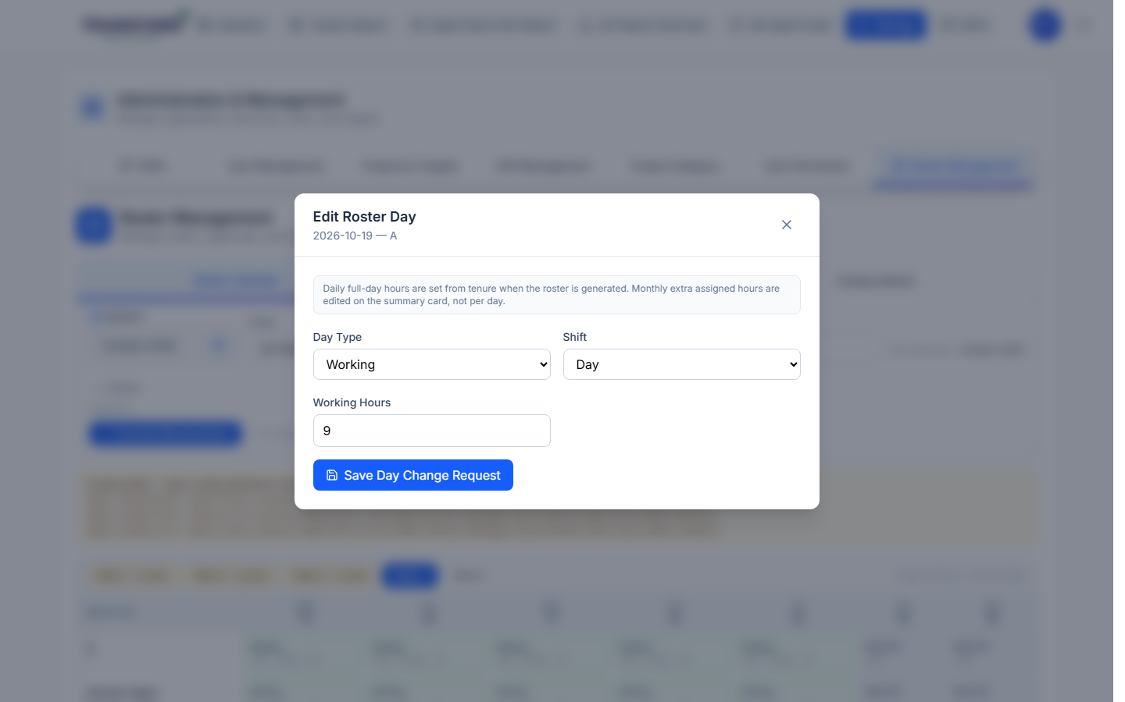
Figure 3: Edit Roster Day - Working
2. Working / Week Off: choose Day Type, Shift (Day or Night) and, for Working, the Working Hours. Click Save Day Change Request.
3. Leave: choose Leave (Roster) for planned leave or Leave (Unrostered) for unplanned leave. Tick Half Day if they work half the day. Tick Affect Target to reduce the monthly working days and hours; leave it unticked to keep the full target. Click Save Leave Request.
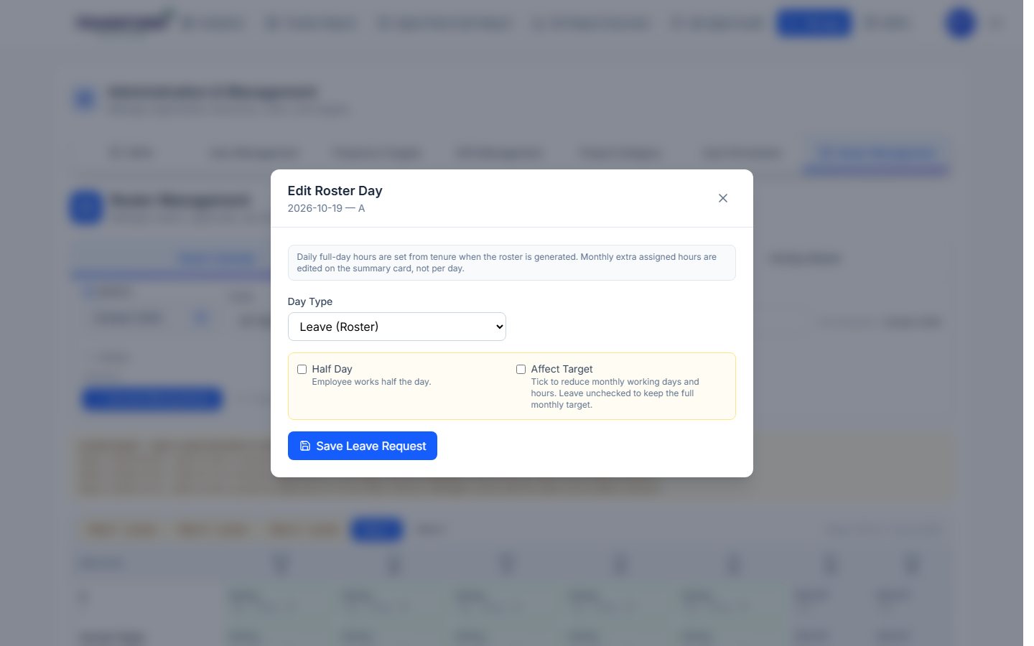
Figure 4: Leave options - Half Day and Affect Target
4. Left: choose Left when the person stops coming from that date. Keep 'Apply Left from this date through the end of the month' ticked to mark every remaining day.
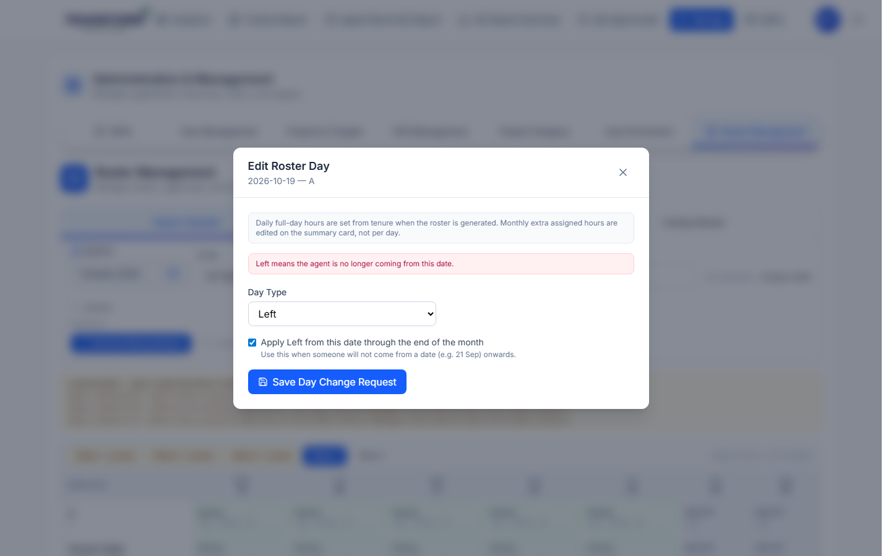
Figure 5: Left
5. The cell now shows the new value with an amber dot (draft). Nothing changes for targets until admin approves.
6. Changed your mind before submitting? Open the same day again and save the new value. It replaces the earlier draft, so only one change per day goes to admin.

6. Procedure - Submit for approval
1. When your drafts are ready, the yellow bar shows 'N saved change(s) are not submitted yet'. Click Submit for approval and Confirm.
2. Each week you edited goes to admin. While it is waiting, that week cannot be edited ('Week N has pending approval requests; withdraw or wait for review').
3. After approval the change is applied, targets are recalculated and the week is locked.
4. Approving does not send the roster email. Admin uses Send email on the week tab.

7. Procedure - Track or withdraw your changes
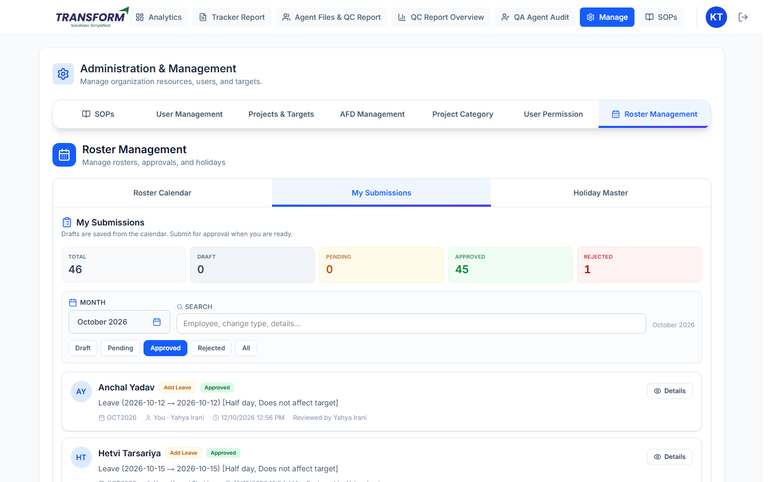
Figure 6: My Submissions
1. Open My Submissions. The cards show Total, Draft, Pending, Approved and Rejected for the month.
2. Filter Draft / Pending / Approved / Rejected / All and search by employee, change type or details.
3. Open Details to see the requested change and the reviewer's note. A rejected request shows the reason.
4. To remove a draft before submitting, click Withdraw (or Withdraw draft in Details).

8. Procedure - Excel upload (many changes at once)
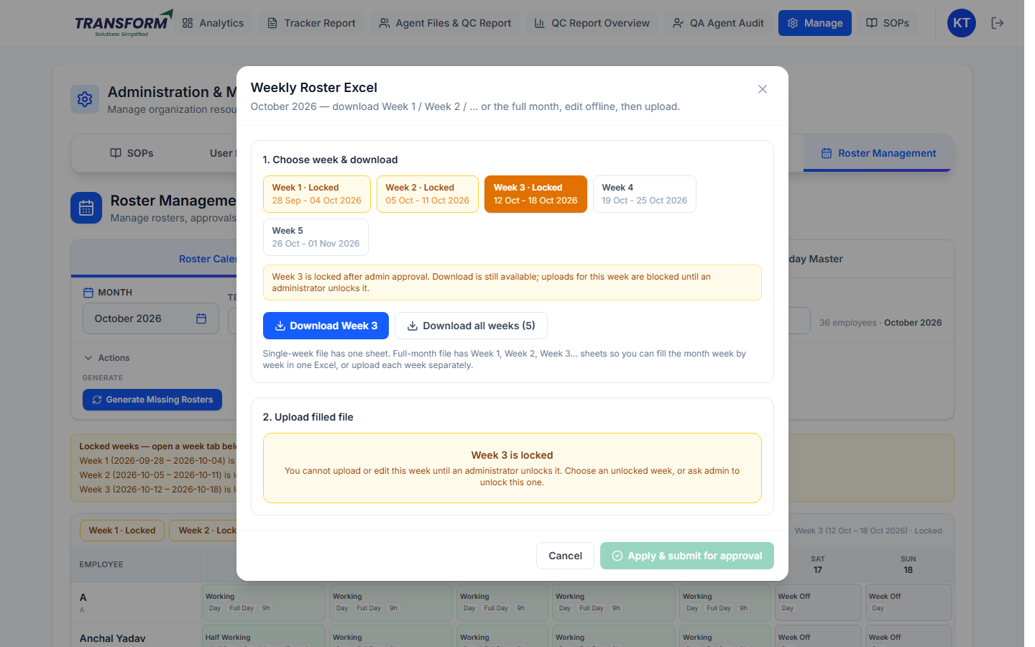
Figure 7: Weekly Roster Excel
1. Click Actions > Excel Upload. Choose the week. Locked weeks are amber and cannot be uploaded.
2. Click Download Week N (one sheet) or Download all weeks (one sheet per week).
3. Fill the file offline and upload it in '2. Upload filled file'. The preview shows changes, unchanged rows and errors. Fix errors and upload again if needed.
4. Click Apply & submit for approval. The changes are saved and that week is submitted for approval at once.

9. Other things on this page
- Holiday Master lists the holidays for a year (search by name or date). Only admins can change them.
- Monthly extra assigned hours are changed on User Monthly Goal, not on the roster. Negative values reduce the goal.
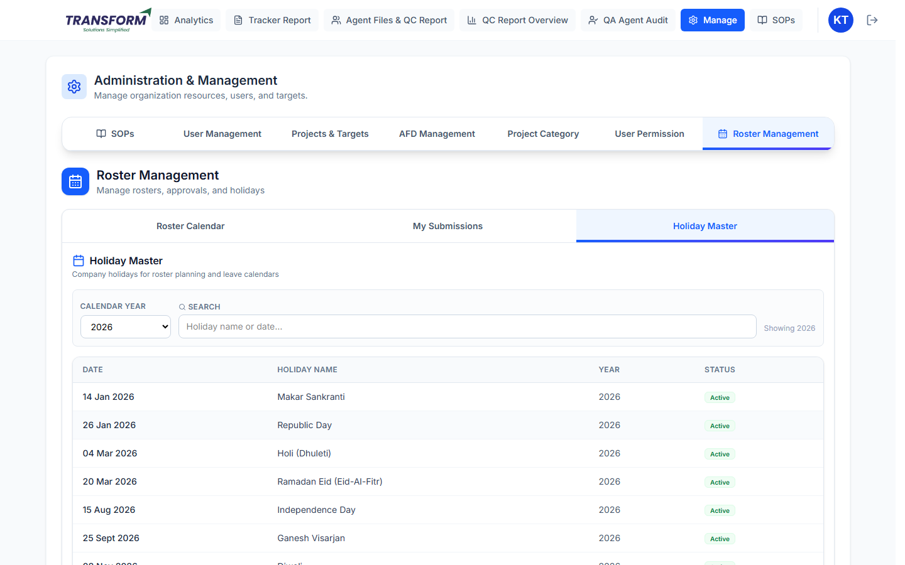
Figure 8: Holiday Master (view)

10. Rules to remember
- The employee needs a tracker joining date before their roster can be edited.
- Leave and half day cannot be added on a holiday. Set Working (day or night) if the person must work.
- One change per employee per day: a newer draft replaces the older one.
- Approved weeks are locked. Ask admin to unlock a week before changing it again.
- Half-day leave and half working days count as half a working day in KRA.

11. Common problems
Problem | What to do
Cannot click a day | The week is locked, the month is locked, or the week has a change waiting for approval. Ask admin, or withdraw your submission.
'Tracker joining date is not set' | Ask admin to set the joining date in User Management.
'No employees for this filter' | Generate missing rosters or choose another team.
Single Employee is greyed out | Type the name until only one employee remains.
Change shows but targets did not change | It is still a draft or pending. Submit it and wait for approval.

